**Day 8: Different Types Of Model**

1. **Waterfall Model:-**

* It’s the first model to introduced.
* It’s also known as a linear-sequential life cycle model.

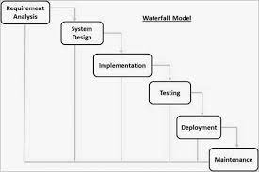

Fig:- Waterfall Model

Advantages of Waterfall model

* This model is simple to implement.
* It gives clarity for the customer to release date for the complete product.

Disadvantages of Waterfall model

* In this model, the risk factor is higher.
* This model cannot accept the changes in requirements during development.
* It becomes tough to go back to the phase.

**2)V Model:**

* It’s also referred as Verification & Validation.
* Verification comes in **Quality Assurance.**
* Validation comes in **Quality Control.**
* Verification is on one side and Validation on other side is joined by Coding phase in V-Shape, That’s why it’s called as “V-Model.”

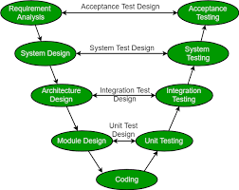

Fig: V Model

It Includes Various Testing Phase As Follow:

1. Unit Testing
2. Integration Testing
3. System Testing
4. Acceptance Testing

**3)Prototype Model:**

 It is used for obtaining customer feedback as described below:

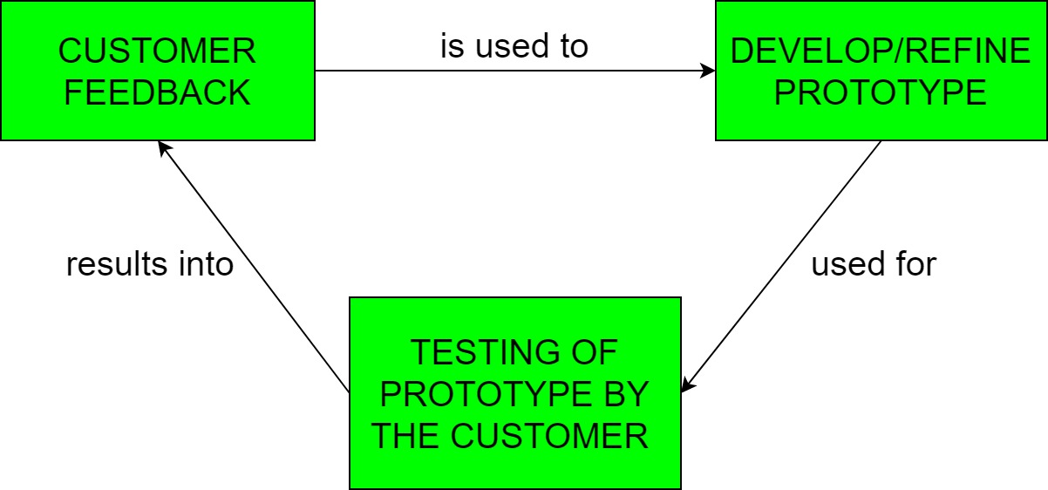

* The Prototyping Model is one of the most popularly used Software Development Life Cycle Models (SDLC models).
* The process continues until the user approves the prototype and finds the working model to be satisfactory.

**4) Spiral Model:-**

* It’s the iterative feature of prototyping with the controlled and systematic aspects of the linear sequential model.
* Following Figure illustrate this:

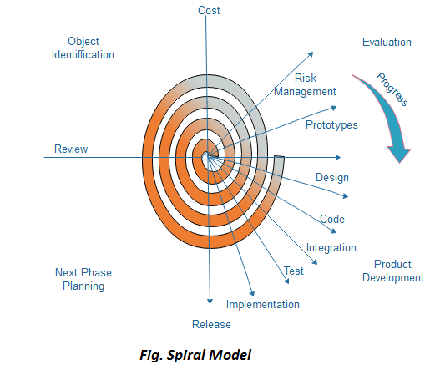

Advantages

* Useful for large and mission-critical projects.

Disadvantages

* Can be a costly model to use.
* Risk analysis needed highly particular expertise.

**5)Agile Model:-**

* The meaning of Agile is swift or versatile.
* "**Agile process model**" refers to a software development approach based on iterative development.
* Agile methods break tasks into smaller iterations, or parts do not directly involve long term planning.

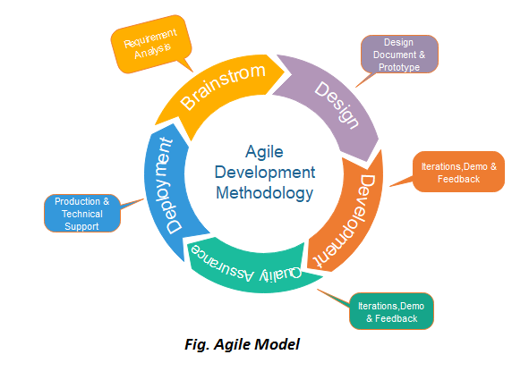

Phases of Agile Model:

Following are the phases in the Agile model are as follows:

1. Requirements gathering
2. Design the requirements
3. Construction/ iteration
4. Testing/ Quality assurance
5. Deployment
6. Feedback

Advantages of Agile Method:

1. Frequent Delivery
2. Face-to-Face Communication with clients.
3. It reduces total development time.

Disadvantage of Agile Model:

1. Due to the shortage of formal documents, it creates confusion and crucial decisions taken throughout various phases can be misinterpreted at any time by different team members.